**CS-564 ML: Assignment 4**

Task: Implemented a feedforward neural network for BBC News text classification into five categories, business, entertainment, politics, sport and tech.

Pre-processing

* Considered 50 words per article
* Removed all stopwords
* Converted all words to lower case and removed all punctuations.
* Performed stemming on each word

Results: 70-10-20 (Train-Val-Test Split)

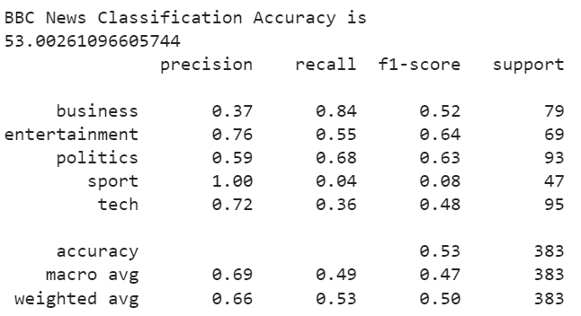

Variation Studies:– Using activation ‘tanh’ for intermediate layers.

Overall Results:

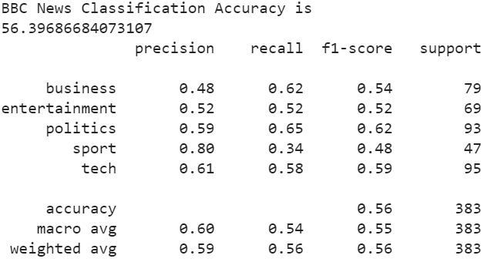

Cross-Validation:

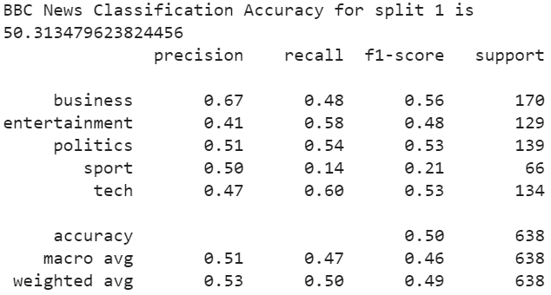

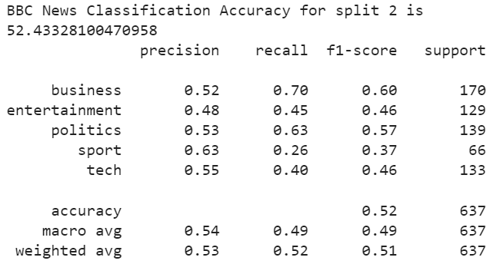

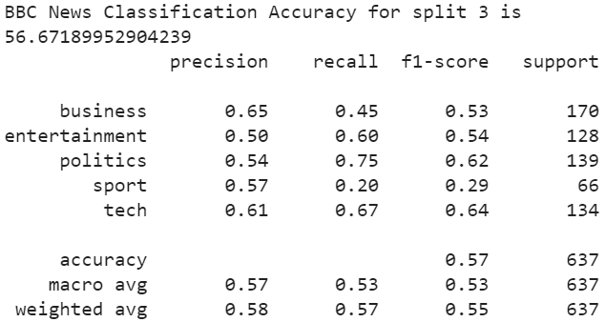

We can see that the overall accuracy using tanh is 56.39%. In general, using tanh performs slightly better than using relu

Variation Studies: Using SGD optimizer instead of Adam.

Overall Accuracy:

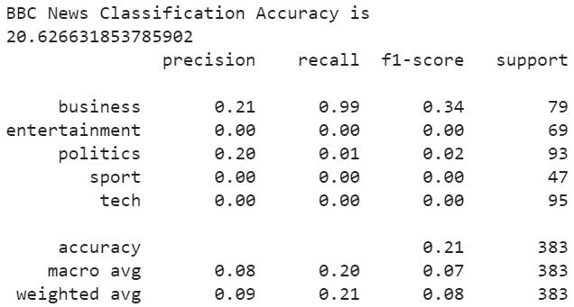

Cross-Validation:

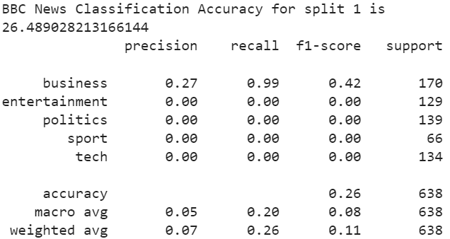

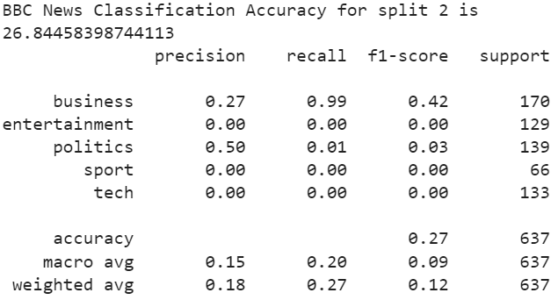

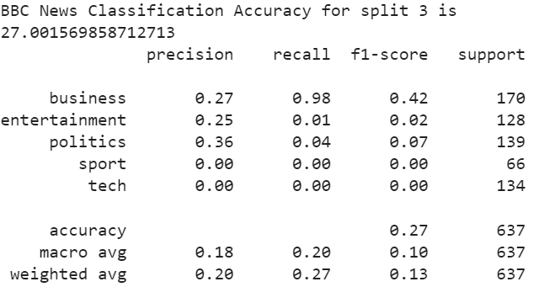

We can see that the overall accuracy using SGD optimizer is only around 20-26%. The Adam optimizer is much better than SGD as an optimizer.